Assignment-4 (BootStrap)

Subject: CSW1 (CSE2141)

Session: Sep 2021 to Jan 2022

Branch: CSE&CSIT Section: All

1. Create a page and add table. Make sure the table is responsive and renders nicely on all types of screen sizes.

2. Create a registration page and add fields like name, address, etc. to capture data. Also add alerts if user is going to close the window.

3. Create a page and add file upload functionality. Then add a progress bar so that you can show the progress of file upload.

4. Create a page to show data in a graphical form. Use bar and pie charts to show the last 7 days weather data.

5. Create a page and add Grid to show stock prices data of Apple.

6. Deasign a new year card gallery using bootstrap card. Card should contain the description about the card below the image with a link as shown below. You may add some more properties to give a nice look.

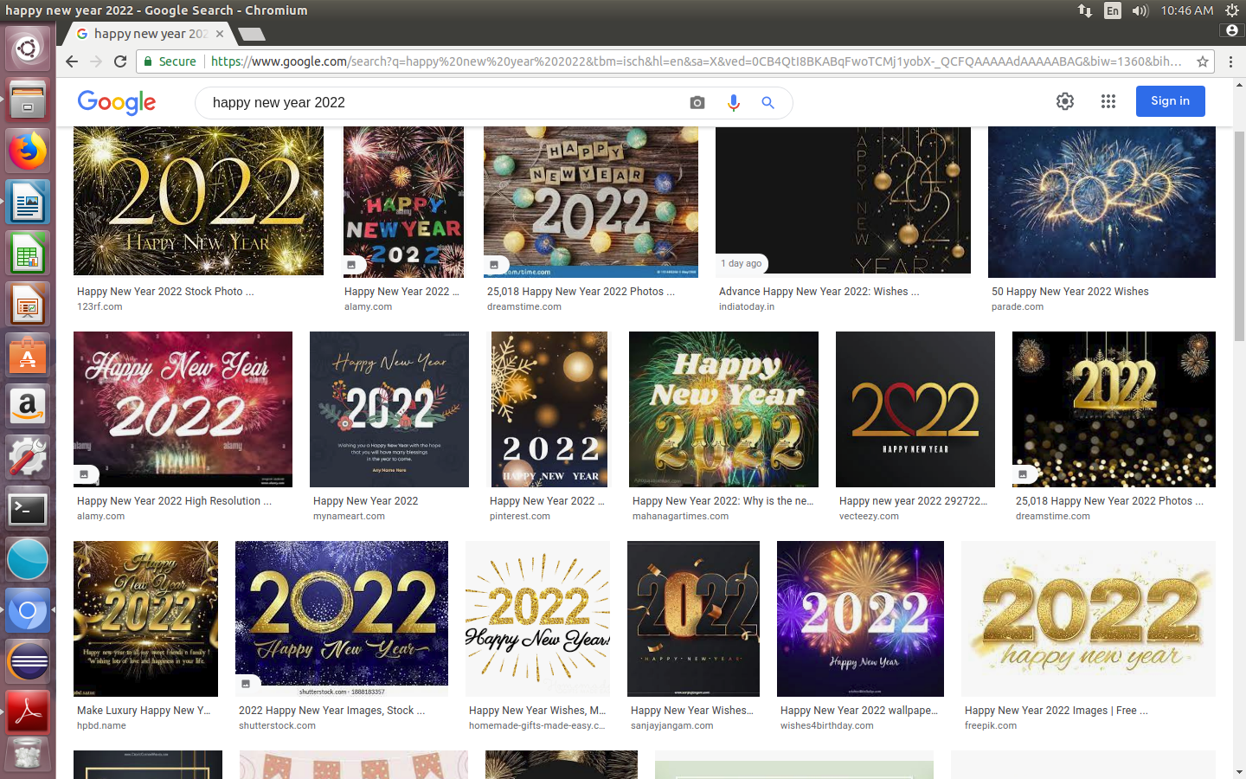

7. Design a front end technology tutorial web page as follows using jumbotron , nav bar and pagination.

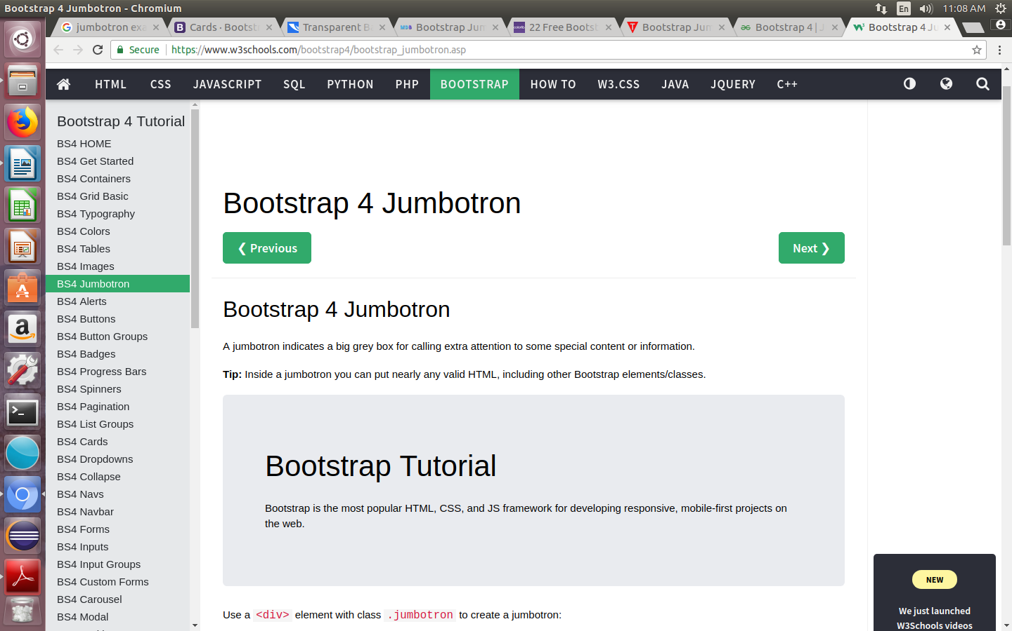

8. Design a webpage to upload your profile using bootstap card and form as follows.

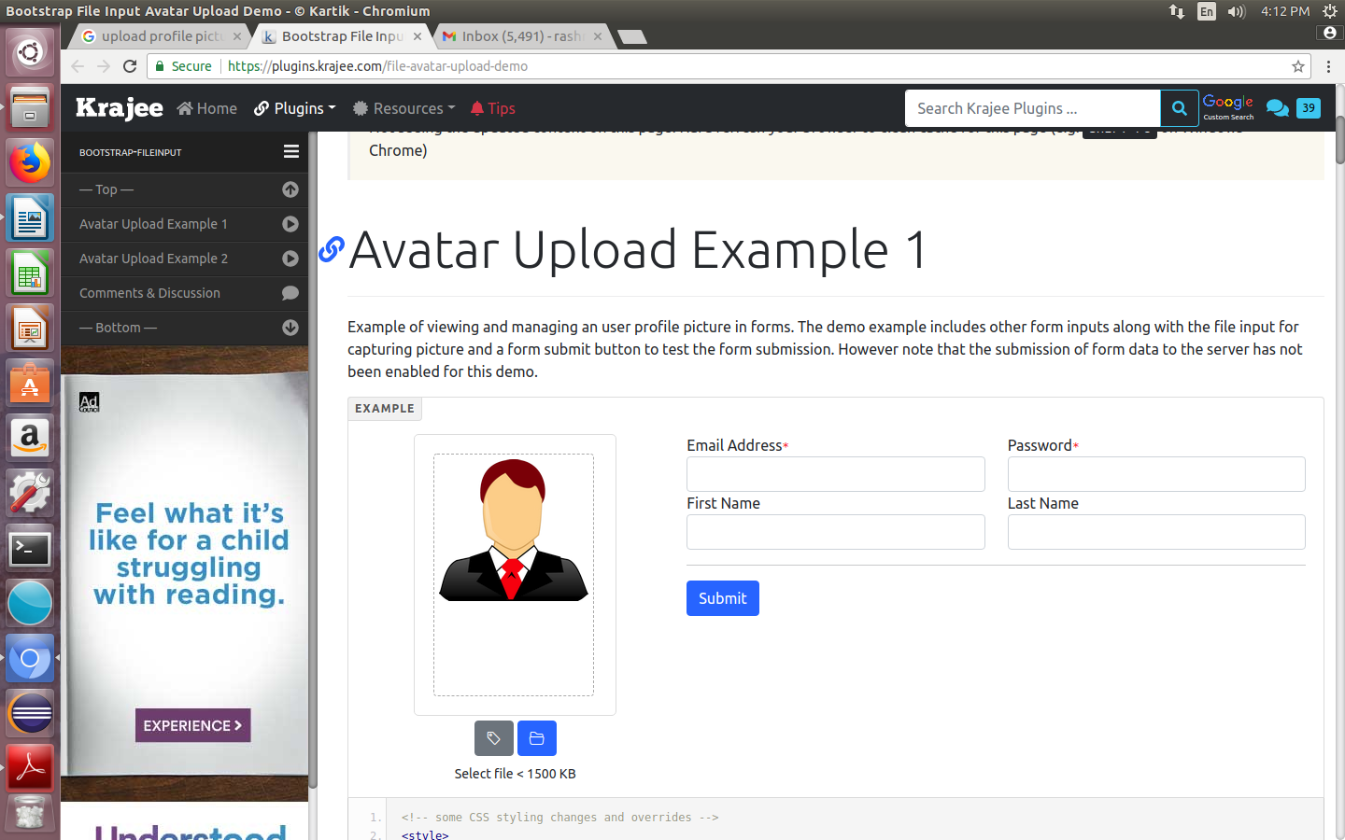

9. Design a slide show of animals using carousel.

10 . Design a checkout form as below

